Spring Boot – Testing API with MockMvc

- GET request – to check if that get request is successful
@Test
public void testExample() throws Exception
{
mockMvc.perform(get("/students/all")).andExpect(status().isOk());
}
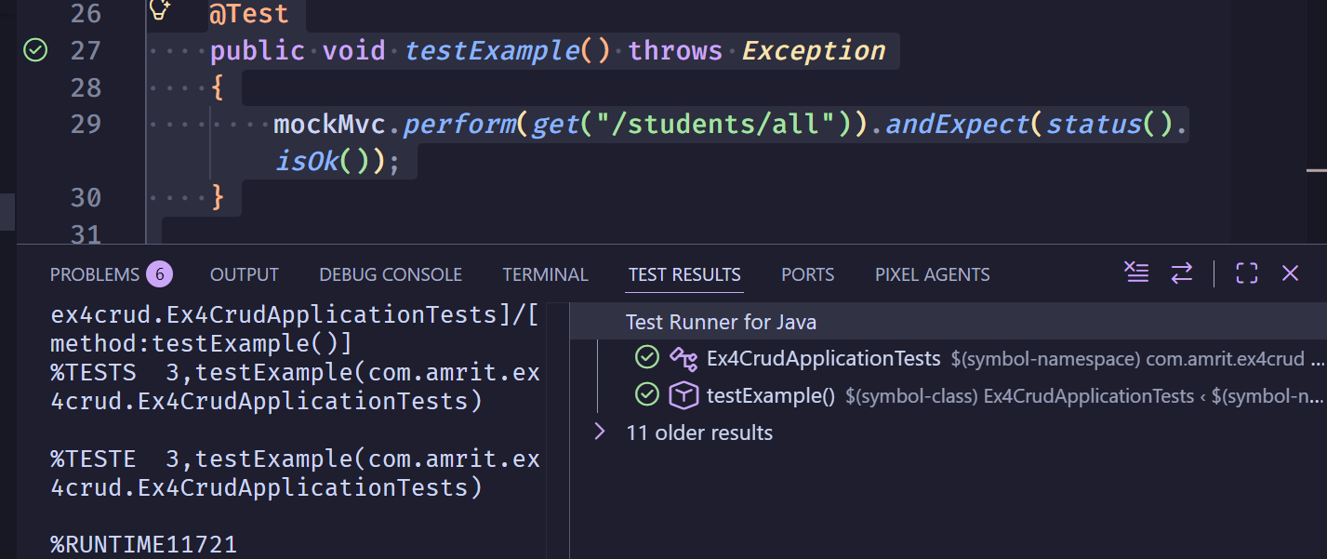

- GET Request – to check if that get request is not successful (path is changed)

In controller:

@RestController
@RequestMapping("/students")
public class StudentController {
…..
@GetMapping("/all")
public List<Student> getAllStudents() {
return studentRepository.findAll();
}
….
}

@Test
public void testExample() throws Exception
{
mockMvc.perform(get("/students/all/")).andExpect(status().isOk());
}
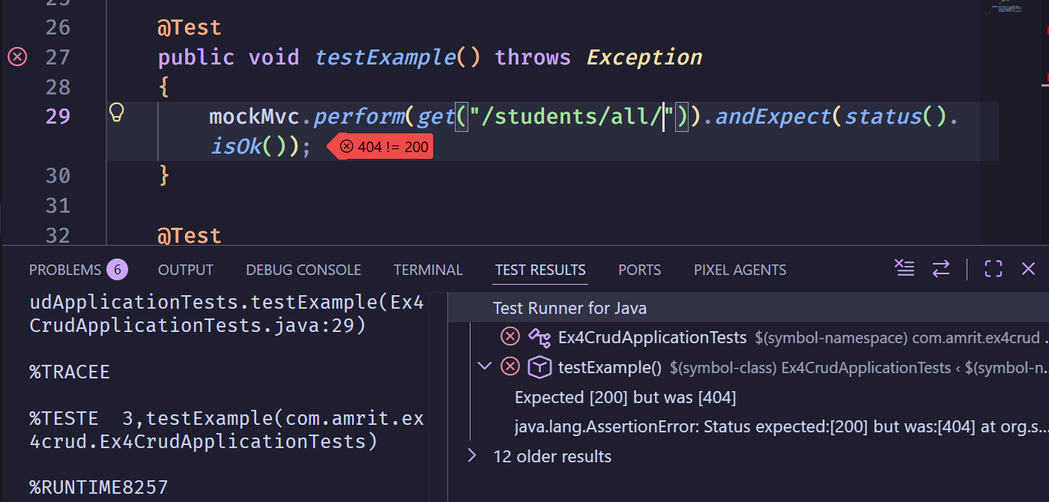

- POST Reuqest – To check if the insertion is successful
@Test
public void testCreateStudent() throws Exception {

String studentJson = """
{
"rollNo": 3,
"name": "Arun",
"department": "ECE",
"year": 3,
"cgpa": 9.1
}
""";

mockMvc.perform(post("/students/add")
.contentType("application/json")
.content(studentJson))
.andExpect(status().isOk());
}
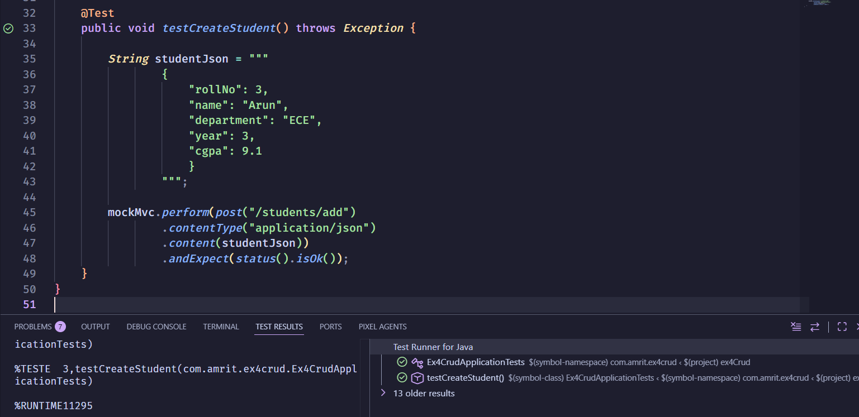

- POST Request – Removing a value in the request body and checking if it is robust against invalid body

String studentJson = """
{
"rollNo": 3,
"name": "Arun",
"department": "ECE",
"year": 3,
}
""";

mockMvc.perform(post("/students/add")
.contentType("application/json")
.content(studentJson))
.andExpect(status().isOk());

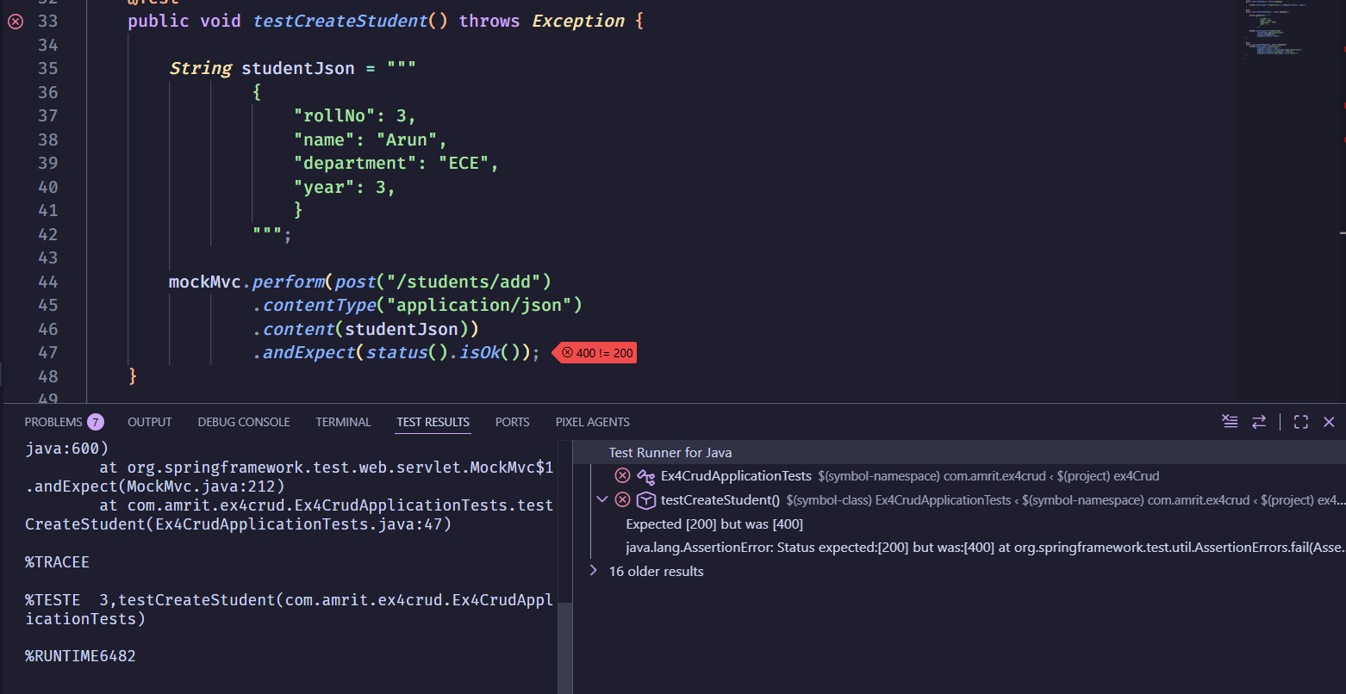

- POST Request – Checking if the return code is 201 (CREATED) – by default string returns status 200 (OK) for all successful API execution
@Test
public void testCreateStudent() throws Exception {

String studentJson = """
{
"rollNo": 3,
"name": "Arun",
"department": "ECE",
"year": 3,
"cgpa": 9.1
}
""";

mockMvc.perform(post("/students/add")
.contentType("application/json")
.content(studentJson))
.andExpect(status().isCreated());
}

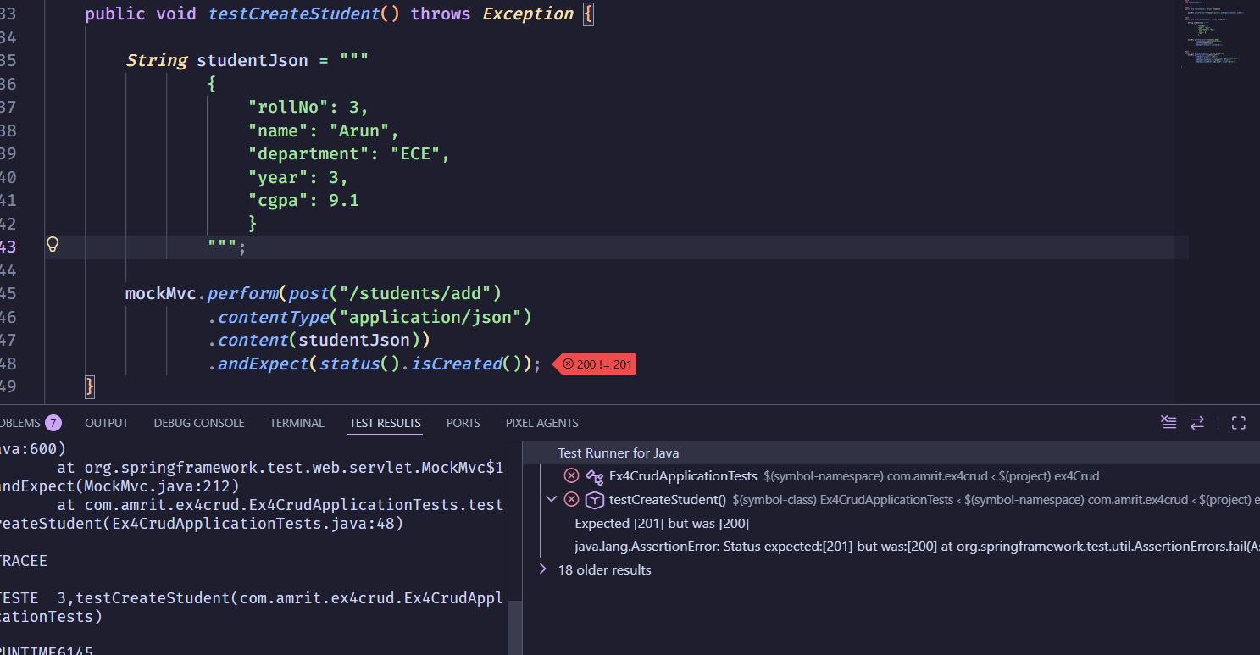

- Changing POST endpoint in Controller to explicitly return status code 201 (CREATED) and testing POST endpoint

In controller:

@RestController
@RequestMapping("/students")
public class StudentController {
……

@PostMapping("/add")
@ResponseStatus(HttpStatus.CREATED)
public Student createStudent(@RequestBody Student student) {
return studentRepository.save(student);
}

…..
}

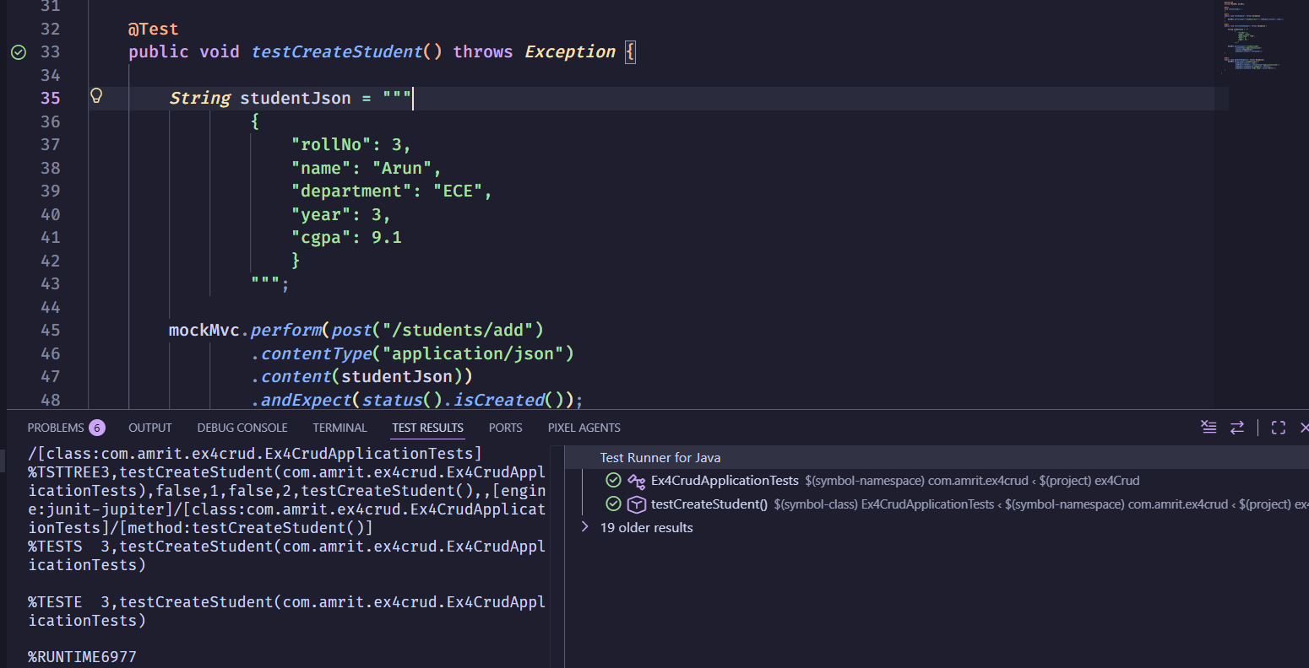
- GET request – We are expecting 2 documents, but getting 3
@Test
public void getUserResponse() throws Exception{
mockMvc.perform(get("/students/all"))
.andExpect(status().isOk())
.andExpect(content().contentType("application/json"))
.andExpect(jsonPath("$.length()").value(2))
.andExpect(jsonPath("$[0].name").value("Amrit"));
}
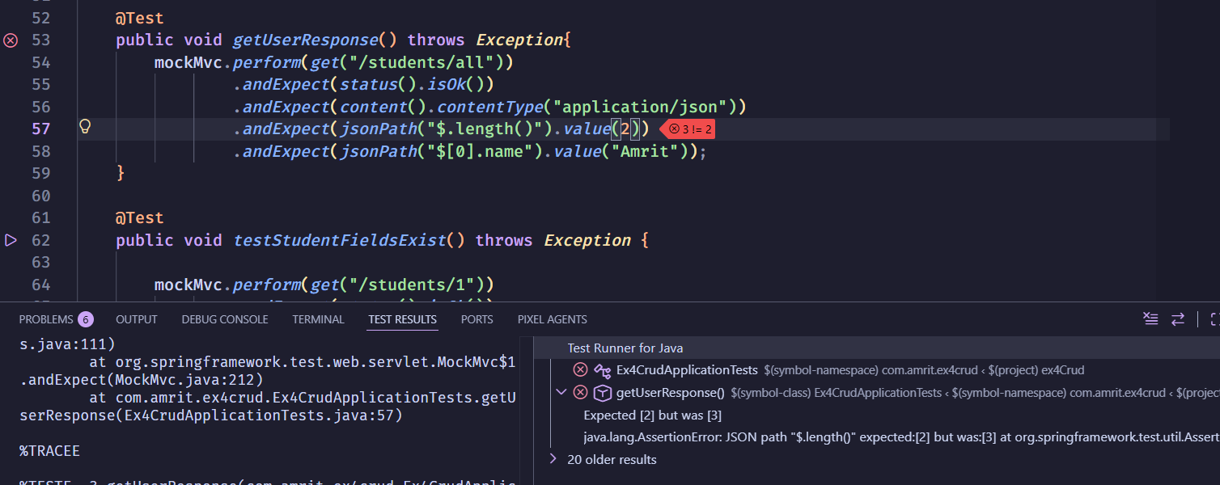

- GET Request – Correct response count (3 documents), the first document’s name is “Amrit”
@Test
public void getUserResponse() throws Exception{
mockMvc.perform(get("/students/all"))
.andExpect(status().isOk())
.andExpect(content().contentType("application/json"))
.andExpect(jsonPath("$.length()").value(2))
.andExpect(jsonPath("$[0].name").value("Amrit"));
}

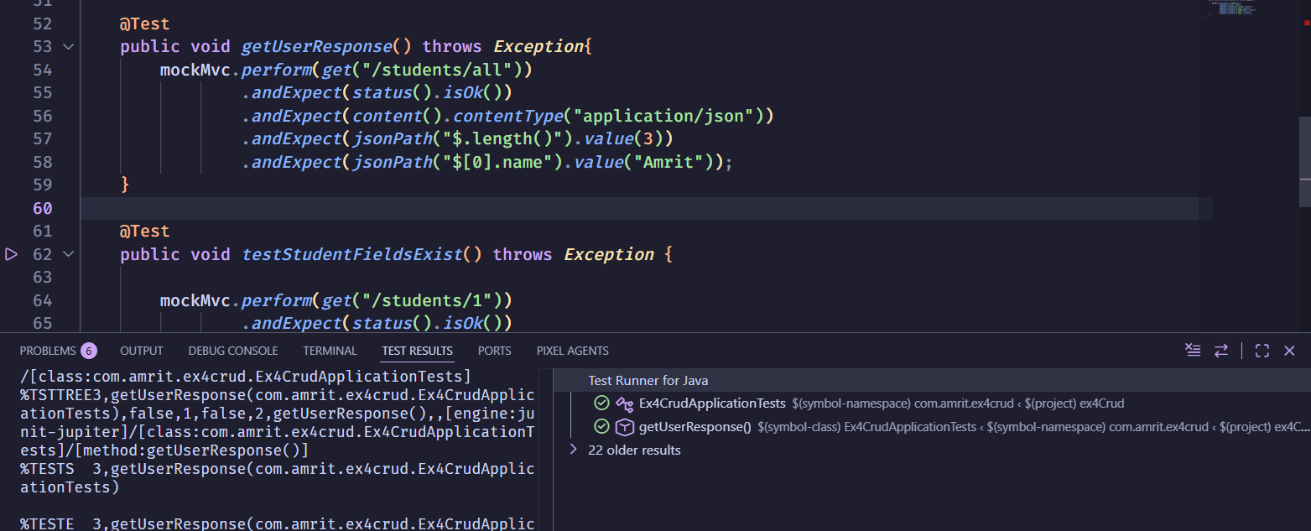

- GET Request – Checking if the structure of response is correct (ie schema of the document)
@Test
public void testStudentFieldsExist() throws Exception {

mockMvc.perform(get("/students/1"))
.andExpect(status().isOk())
.andExpect(jsonPath("$.rollNo").exists())
.andExpect(jsonPath("$.name").exists())
.andExpect(jsonPath("$.department").exists())
.andExpect(jsonPath("$.year").exists())
.andExpect(jsonPath("$.cgpa").exists());
}

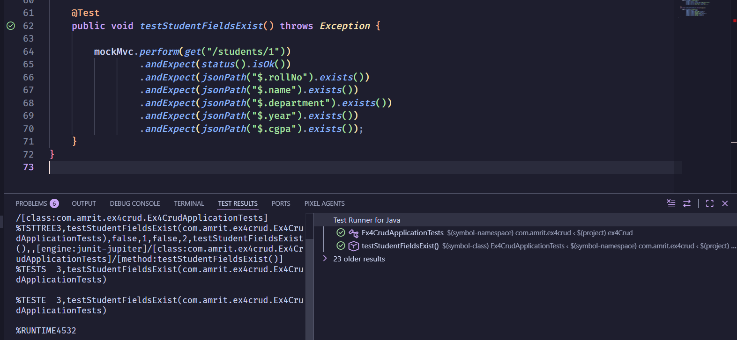

- GET Request – We are getting an incorrect structure – expecting a structure but getting a different one

@Test
public void testStudentFieldsExist() throws Exception {

mockMvc.perform(get("/students/1"))
.andExpect(status().isOk())
.andExpect(jsonPath("$.rollNo").exists())
.andExpect(jsonPath("$.name").exists())
.andExpect(jsonPath("$.email").exists())
.andExpect(jsonPath("$.department").exists())
.andExpect(jsonPath("$.year").exists())
.andExpect(jsonPath("$.cgpa").exists());
}

